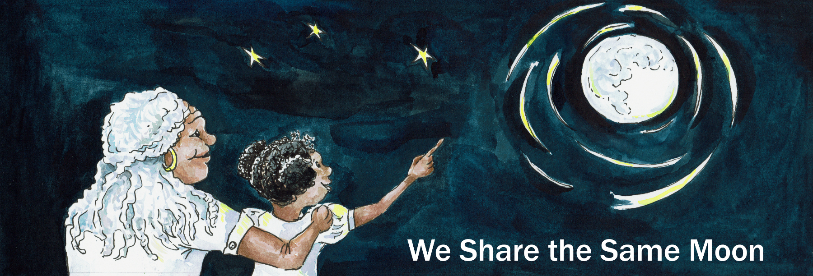
Suggested Age Range: 4 - 5 years; 5 - 6 years; 6 - 7 years;
UK Curriculum: Foundation Stage; Key Stage One
Suggested UK Year Group: Year One
UK Primary Curriculum Link: Everyday Materials
Science Subject: The Sky, Sun, Moon and Earth
Science Questions: What do we see in the Sky?
Suggested Science Activity: Eclipse
Children with SEND: Use to boost comprehension of science vocabulary
EAL children: Beginners Level
Country of Origin: South Korea
Source: The Story Bag by Kim So-un. Contributed by Lois Keel

Long ago, according to Korean legend, there were many, many worlds spinning across the sky.

One those worlds was OUR world, the Planet Earth! The planet Earth was special because above our planet, the Sun shone, all through the day and the Moon was bright all through the night. And our planet was surrounded with shining, sparkling light day and night. And so our world, the planet Earth was called the World of Light.

But, what about the other worlds?

There was one world, far across the sky, a long, long way from the planet Earth that had NO Sun and NO Moon - it had no light at all.
And this world was called, the world of Darkness.

And, as for all the animals and all of the people living in the the World of Darkness, well as you can imagine - it was very difficult!
Nobody could see where they going! And they kept bumping into things, all of the time!

One day, rabbit was hopping along and hopping along and he hit his nose upon a rock. PENG! And it hurt! Ouch!
And Rabbit was cross. Enough is Enough - We need some light!
One day, Tiger was walking along and walking along and he hit his nose upon a tree. PENG! And it hurt! Oo.Ouch!
And Tiger was very cross. Enough is Enough - We need some light!
One day, Eagle was flying along and flying along and he hit her nose upon a mountain. PENG! And it hurt. Oo Ouch. Oo!
And Eagle was very, very cross. Enough is Enough - We need some light

So all of the animals and all of the people, gathered together and they all agreed:
Enough is Enough - We need some light!

So, they marched to see their King.

Enough is Enough - We need some light!
Enough is Enough - We need some light!
Enough is Enough - We need some light!

Now, it so happened that the King of Darkness, had a dog, who loved him very much!
This dog would do anything for the King, and he could run as fast as the wind.
So, when the people from the land of darkness came to ask for some light, the king had an idea!
He would send his dog to steal some.

The King looked into the distance and saw the Sun shining over our planet Earth and he thought; “Ahah, that is what I want!”
The King turned to the dog. He pointed at the Sun.
And the King said: Fetch me the Sun!
WOOF said the dog “Yes master!”

So the huge dog galloped across the dark sky, his great big feet slapping against the air
Gdom, Gdom Gdom! Gdom Gdom, Gdom!
It was such a long way!
Gdom, Gdom Gdom! Gdom Gdom, Gdom!
He began to grow tired.
Gdom, Gdom Gdom! Huh, huh, huh!
Gdom, Gdom Gdom! Huh, huh, huh!
It was so far, but he kept on going!
Gdom, Gdom Gdom! Gdom Gdom, Gdom!
And, as he got closer and closer and closer to the Sun, the air grew hotter and hotter and hotter.
The dog began to pant in the heat. Phew! Phew! Phew!

Gdom, Gdom Gdom! Phew! Phew! Phew!
Gdom, Gdom Gdom! Phew! Phew! Phew!

It was so hot, But he kept on going! He had to do what the King had asked!
Gdom, Gdom Gdom! Gdom Gdom, Gdom! Gdom, Gdom Gdom!
Until at last, he reached the Sun.

The dog opened his great mouth and took a huge bite - Ohm!
And it hurt! Ooooooooooow!
The Sun was so hot, it burnt his mouth. Ooooooooooow!
He closed his jaws around the Sun, and began to pull it back through the Sky
Meanwhile on the planet Earth, the people saw their Sun begin to disappear!
It grew dark!

What is happening to our Sun? Someone is trying to steal it!
Quick - we must scare them away!

And they grabbed their drums and began to drum.

Peng, Peng, Peng, Peng, Peng! Peng, Peng, Peng, Peng, Peng!
Peng, Peng, Peng, Peng, Peng! Peng, Peng, Peng, Peng.

Up in the sky, the poor dog heard the noise.

Peng, Peng, Peng, Peng, Peng! Peng, Peng, Peng, Peng, Peng!
Peng, Peng, Peng, Peng, Peng, Peng, Peng, Peng, Peng.

And it hurt! Oooooooow! His ears began to hurt.
his mouth, his ear hurt and so he realised, he could not do it!
He could not steal the Sun! And the dog let go!
And the poor dog whimpered all the way home!
Whine, whine, whine, whine, whine!

Gdom, Gdom Gdom! Whine, whine, whine, whine, whine! Gdom, Gdom Gdom!

By the time he got back to the land of darkness, his mouth hurt, his ears hurt and his paws hurt! Everything hurt! Whine!

He galloped up to his King and flopped down at his feet.
And the dog said: Whine, whine, whine, whine, whine!
Very sorry! I could not do it. The Sun is just too hot!

And the King was furious!
What! What?What!You have disobeyed my command!
Too hot! Too hot? Too hot! This is NOT good enough - you must try again!

The King looked once more into the distance.
And now, he could see the Moon shining over the Planet Earth.
The King turned to his dog and pointed to the Moon and he said:
Fetch me the Moon!

WOOF said the dog “Yes master!”

So the huge dog galloped across the dark sky, his huge feet slapping against the air.
Gdom, Gdom Gdom! Gdom Gdom, Gdom! Gdom Gdom, Gdom!
It was such a long way!
Gdom, Gdom Gdom! Gdom Gdom, Gdom! Gdom Gdom, Gdom!
He began to grow tired.
Huh, huh, huh!
Gdom, Gdom Gdom! Huh, huh, huh!
Gdom, Gdom Gdom! Gdom, Gdom Gdom!

It was so far, but he kept on going!
And as he got closer and closer and closer to the Moon, the air grew colder and colder and colder.
And the dog began to shiver.
Brr, brr, brr!
Gdom, Gdom Gdom! Gdom, Gdom Gdom! Gdom, Gdom Gdom!
Brr, brr, brr! Brr, brr, brr! Brr, brr, brr!

Gdom, Gdom Gdom! Gdom, Gdom Gdom! Gdom, Gdom Gdom!
Brr, brr, brr! Brr, brr, brr! Brr, brr, brr!

But he kept on going! He had to do what the King had asked!
Until at last, he reached the Moon .

The dog opened his great mouth and took a huge bite - Ohm!
And it hurt! Ooooooooooow!
The Moon was so cold it burnt his mouth. Ooooooooooow!
But, he closed his jaws around the Moon, and began to pull it back through the Sky
Meanwhile on Earth, the people saw their Moon begin to disappear!

What is happening to our Moon? Someone is trying to steal it!
Quick - we must scare them away!

And once again, they grabbed their drums and began

Peng, Peng, Peng, Peng, Peng! Peng, Peng, Peng, Peng, Peng!
Peng, Peng, Peng, Peng, Peng! Peng, Peng, Peng, Peng.

Peng, Peng, Peng, Peng, Peng! Peng, Peng, Peng, Peng, Peng!
Peng, Peng, Peng, Peng, Peng! Peng, Peng, Peng, Peng.

Up in the sky, the dog hurt the noise! And it hurt! His ears began to hurt,
his mouth, his ears hurt and so he realised, he could not do it!
He could not steal the Moon! And so he let go!
And the poor dog whimpered all the way home!
Whine, whine, whine, whine, whine!

Gdom, Gdom Gdom! Gdom, Gdom Gdom!
Whine, whine, whine, whine, whine!
Gdom, Gdom Gdom! Gdom, Gdom Gdom! Gdom, Gdom Gdom!

By the time he got back to the land of darkness, his mouth hurt, his ears hurt and his paws hurt, everything hurt! Whine whine, whine, whine, whine!
He galloped up to the King and flopped down at his feet.
And the dig said: Whine!
Very sorry! I could not do it. The Moon is just too cold!

The King was furious!
What! What?What!
You have disobeyed me once again!
Too cold! Too cold? Too cold!
This is NOT good enough - you must try again!

Once again the King turned and once again he pointed to the Sun and once again he said: Fetch me the Sun!

And that poor dog, he always tries to do what the King asks!
And that is why, when you see the Sun or Moon begin disappear from view, what we call a Solar or Lunar Eclipse, It is because of that dog trying to steal them once again!

Or at least, that’s what I was told!

Originally created for The Vanishing Sun, Retold with Lunar Planetary Institute’s permission.

